Experiment EO6: Changing Magnetic Fields and Electrical Currents

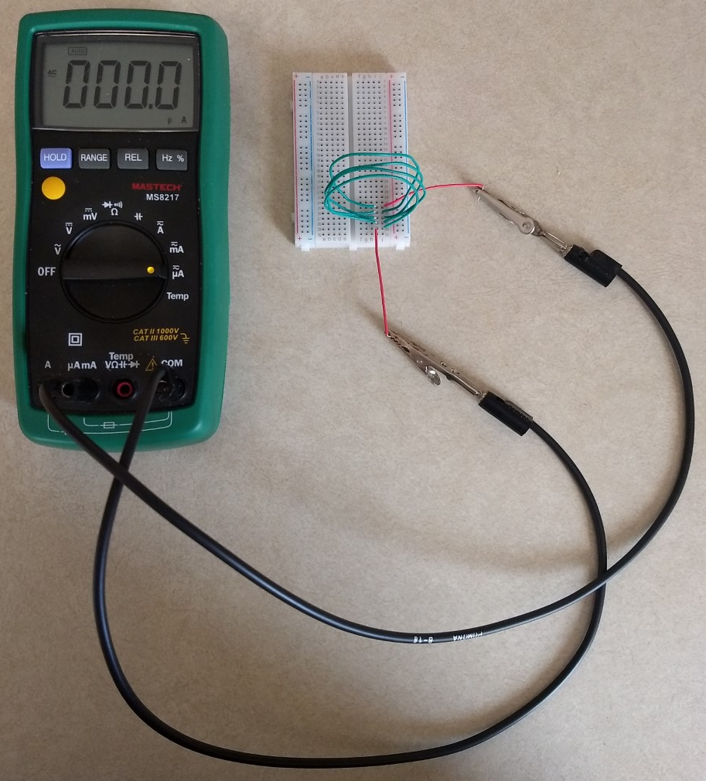

Objectives
- Use a simulation to investigate how changes in speed, number of coils, and polarity of magnet affect the emf in a coil of wire when a magnet is inserted into the coils.
- Use a magnet to create and observe a current in a coil of wire.

Introductory Material
A changing magnetic flux always generates an electric potential, called an emf. That is the principle of Faraday’s Law. The electric potential has a corresponding electric field, which can drive a current in a conductor.

This phenomenon was discovered in 1831 by Michael Faraday. He observed that when a bar magnet is in motion relative to a solenoid, an electric current is induced in the wire of the solenoid. Faraday began his investigation in response to the earlier discovery in 1819 or 1820 by Danish scientist Hans Oersted that magnetism and electricity are related. Oersted discovered this accidentally, during a lecture demonstration, by noticing that an electric current in a wire deflected the needle of a nearby compass. Faraday’s law of induction states that the induced emf in a circuit is proportional to the time rate of change of a magnetic flux passing through it.

The direction of the induced current is predicted by another law, introduced by Russian physicist Heinrich Lenz in 1834:
- An induced emf gives rise to a current such that the magnetic field created by the induced current opposes the change in magnetic flux.
  - This is called Lenz’s Law.

Faraday’s law of induction, together with Lenz’s law, can be expressed mathematically as:

emf = (6.1)

where is the magnetic flux of a uniform field through a flat surface (The direction of the area vector A is normal to the surface). Note that because of Lenz’s law there is a minus sign in this expression.

The interpretation of Lenz’s law may be somewhat confusing at first. It might be understood better if we remember that nature does not like to change its state. If the magnetic flux passing through a circuit is increasing, then an emf and a current are induced so that it weakens the increase of the magnetic flux. Conversely, if the flux through a circuit decreases, the induced current tends to weaken the reduction of flux.

In general, the induced current produces a flux in a direction that opposes the change in the magnetic flux. That is Lenz’s Law.
In this experiment, you will be investigating how a changing magnetic field can create a current in a coil of wire. You will first do this using an online simulation. Once you understand the simulation, you will do it yourself with the breadboard, some jumper wires shaped into coils, a magnet, and a multimeter to detect the current.
Faraday’s law of induction states that the induced emf in a circuit is proportional to the time rate of change of the magnetic flux passing through it. Since the cross-sectional area of the coils is constant in this experiment (exactly so for the simulation, and approximately so for the ones you shape yourself), the magnetic flux passing through the coils can be expressed as the product of the number of windings of the , N, the cross-sectional area, A, and the magnetic field B:

emf (6.2)

We are thus able to induce an emf (and consequently make a current flow) by simply changing the external magnetic field passing through the coils.

Experimental Procedure
Part I: Faraday’s Law Simulation
Open the simulation found here: https://phet.colorado.edu/sims/html/faradays-law/latest/faradays-law_en.html
You can switch between a one or two coil setup by clicking on the appropriate picture at the bottom of the simulation. Select the two coil setup so that the simulation looks like the picture below.
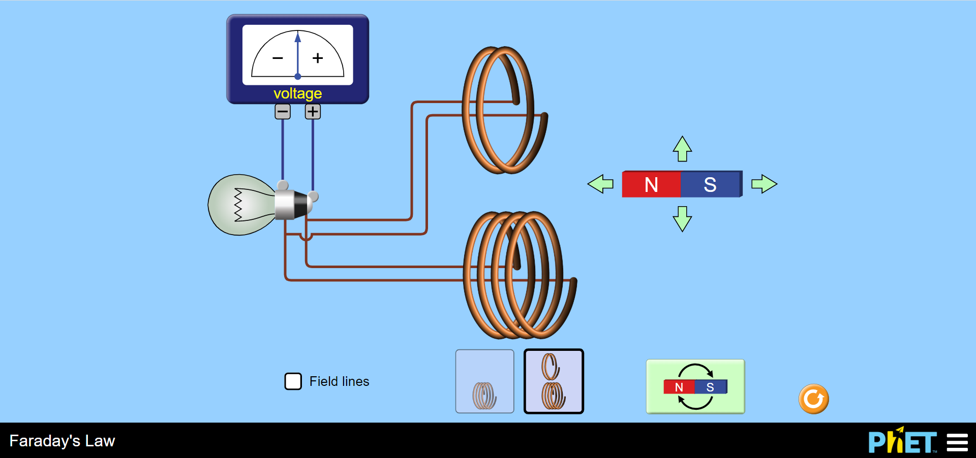
By clicking and dragging on the magnet, you can move it around the screen. Note that you can switch which direction the magnet faces by clicking on the magnet picture at the bottom of the simulation. Go through all the cases listed in the table on your worksheet. Explain what happens in each case, making sure to mention the sign and relative magnitude of the meter. It is recommended that you answer Analysis Question #1 now before moving on to Part II.

Part II: Induce a Current in a Real Wire
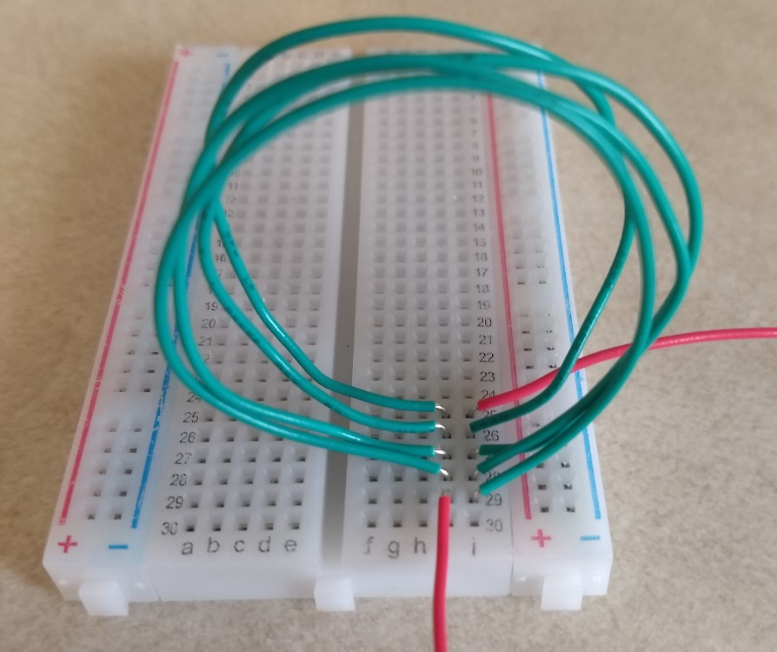
Use four long jumper wires and the breadboard to create a coil with electrical continuity as shown in the picture to the right. You can use the resistance setting to check for electrical continuity. If you connected your wires correctly, you should have approximately zero resistance.
Connect the two ends of your coil to the multimeter, using the COM port and the μA port. Turn the multimeter to the μA setting. The meter is probably in DC mode. If so, push the yellow button to put it in AC mode. See the picture on the cover page for full setup. Now take the magnet, holding it as shown in the picture below right, and move it side to side quickly. With a little practice, you should be able to see a current in the range of about 1.5-3 μA. Record the maximum current you are able to achieve.
Now remove two of the jumper wires so that you have only two coils instead of 4 (make sure you still have electrical continuity). Move the magnet and record the maximum current as before.

Analysis Questions
- Use Equation 6.2 to explain the results for each case in the table on your worksheet for Part I.

- In Part II where you created your own setup, did you notice a difference when you dropped from 4 coils down to 2? Can you use Equation 6.2 to justify this difference (or lack thereof)?

For calculus based courses only: The more general expression for the magnetic flux is . If your field was non-uniform and/or your surface of interest was not flat, you would need to use the integral.

