Experiment EO5: Series and Parallel Resistors

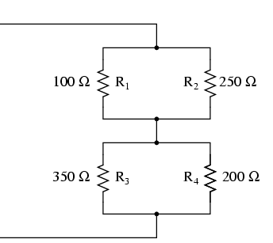

Objectives
- Scientific: Learn about series and parallel circuits.
- Skill Development: Demonstrate ability to use the breadboard independently.

Introductory Material
Just like with capacitors (see Experiment EO3), resistors can be connected in two ways:
- In series
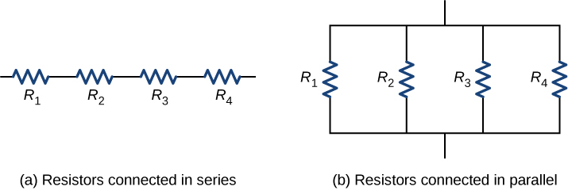
- In parallel
Resistors connected in series Resistors connected in parallel

When you connect resistors in series, it turns out that they look like a single resistor R_{tot}

And when you connect them in parallel,

Resistances in series add, whereas resistances in parallel add through their reciprocals.

Note that this is exactly opposite the case you investigated for capacitors in Experiment E03, where you found that capacitances in parallel add, and capacitances in series add through their reciprocals.

Experimental Procedure
You will be using the multimeter to measure the resistance of three different resistors. If you do not remember how to use the multimeter for resistance measurements, refer to Part I of Experiment EO1. Note that you have previously used the breadboard to connect capacitors both in series and in parallel in Experiment E03. You will only be provide schematics for connecting the resistors in this experiment, but you may refer to the pictures in Experiment E03 if you need help.
Part I: Initial Measurements
Use the multimeter (with banana plug leads and alligator clips) to measure the resistance of all six resistors. Record these resistances on your worksheet.
Part II: Resistors in Series
Use the breadboard to connect the two 100 Ω resistors in series. Use the multimeter to measure the total resistance R_{tot} of these two resistors in series and record it on your worksheet.

Part III: Resistors in Parallel
Use the breadboard to connect the two 100 Ω resistors in parallel. Use the multimeter to measure the total resistance R_{tot} of these two resistors in parallel and record it on your worksheet.

Part IV: Resistors in Series and Parallel Combinations
Use the breadboard to connect five resistors as shown in the schematic below. Use these resistance values: R₁ = 51 Ω, R₂ = R₃ = 1 kΩ, and R₄ = R₅ = 100 Ω. Measure the total effective resistance R_{tot} of the entire combination and record on your worksheet. Take a picture of your assembled resistor combination and paste it into your worksheet.

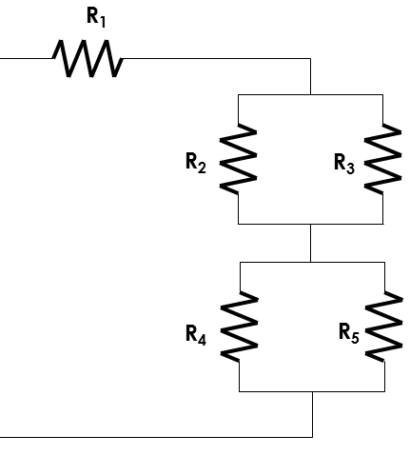

Analysis Questions
- For the two resistors connected in series (Part II), calculate the expected value of R_{tot}, using the measured resistances from the table in Part I on your worksheet. Compare to your measured value of R_{tot} using a percent error: .
- For the two resistors connected in parallel (Part III), calculate the expected value of R_{tot}, using the measured resistances from the table in Part I on your worksheet. Compare to your measured value of R_{tot} using a percent error.

- For the combination of five resistors in Part IV, calculate the expected value of R_{tot}, using the measured resistances from the table in Part I on your worksheet. For this calculation you cannot simply use just Equation 5.1 or Equation 5.2 all in one shot. You will need to break it into pieces. Compare to your measured value of R_{tot} using a percent error.

Hint: Can you find the equivalent resistance of the R₂ and R₃ combination of resistors? Then what could you do to reduce the situation further?

