**Experiment EO4: Ohm’s Law**

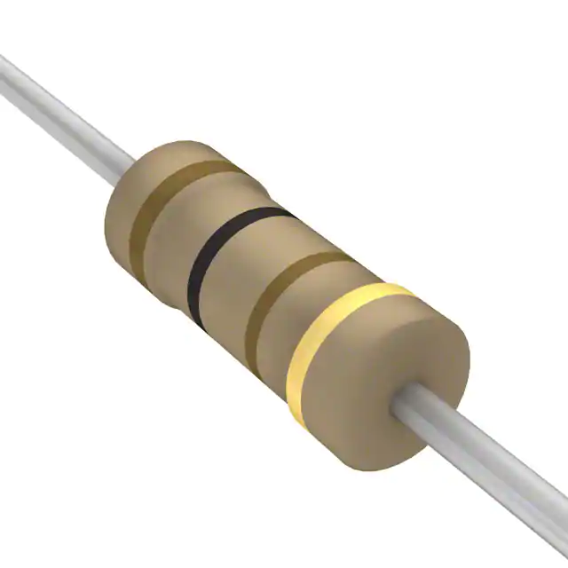

**Objectives**

* *Scientific:* Verify Ohm’s Law.
* *Skill development:* Learn about resistors.
* *Skill development:* Use the breadboard with limited help.

**Introductory Material**

Ohm’s Law is not a fundamental law of nature. Some materials obey it, some don’t. As it happens, most materials do obey it. A copper wire, a lump of mud, and even your sweaty skin … these materials happen to obey Ohm’s Law.

Ohm’s Law deals with two things:

* the electric potential drop *V* [measured in volts, (V)] that is applied across the object
* the current *I* [measured in amperes, (A)] that passes through an object

For most materials, the two are proportional, *V*   *I*.

When you look at the relation *V*   *I*, you can see that there must be a proportionality constant. That constant is the *resistance* of the material, *R*, which has units called ohms (). Expressed as an equation, Ohm’s Law is:



The power, *P,* dissipated in the resistor is given by:



There are some things we should say about an object’s resistance, *R*:

* *R* depends on the material. Specifically, it depends on the resistivity () of the material. Resistivity is measured in ·m.
* *R* also depends on the geometry of the object.
* If the material has a uniform cross section, the resistance is given by:



where *l* is the length of the material and *A* is the cross-sectional area.

* R can also change significantly with temperature, which is one reason that some materials do not follow Ohm’s Law.

The symbol for a resistor that is used in circuit diagrams is shown below:



A circuit diagram for a very simple circuit with one battery and one resistor is shown below. The voltage (V) *across* the resistor is supplied by the battery and there is a current (I) that runs *through* the resistor. The resistor itself (R) is on the right, represented by the symbol described above.

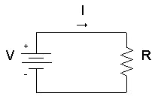

The nominal resistance of a resistor is indicated by four colored bands on the resistor. The values are listed in the table below right. Here’s how you read them:

* 

  Color XYZ

  Black 0

  Brown 1

  Red 2

  Orange 3

  Yellow 4

  Green 5 Color T

  Blue 6 Blank 20%

  Violet 7 Silver 10%

  Gray 8 Gold 5%

  White 9

  Figure 5-6. Resistance color code.

  The *value* of the resistance is determined by writing the numerical value of *X* followed by the numerical value of *Y*, which is then followed by the number of zeros corresponding to the numerical value of *Z*.
* The *tolerance*, or range of possible values, of the resistance is given by the color of the fourth band.
* Example: a resistor with green, blue, red, silver would be 56  102 = 5600 , with a tolerance of ± 10%.

*Be careful not to short-circuit the battery.*

A short circuit is when a wire makes a closed path from one battery electrode to another. If you do create a short circuit, the battery will get hot and it will soon lose its charge and become worthless.

*If you should discover that the battery is hot, immediately disconnect it.*



DON’T DO THIS:

this battery has been short-circuited.

**Experimental Procedure**

Part I: Resistors

*You will be using the multimeter to measure the resistance of three different resistors. If you do not remember how to use the multimeter for resistance measurements, refer to Part I of Experiment EO1.*

Use the multimeter (with banana plug leads and alligator clips) to measure the resistance of resistors with nominal resistances of: 51    and 1 k Record these resistances on your worksheet.

Now look at the colored bands on each of the above resistors.* Record the color code of each resistor on your worksheet, and write down the resistance (including the tolerance) indicated by that color code. If the resistance determined from the color code does not agree with the nominal and measured resistances, carefully review the color code information from the introductory material and try again.

* *If you are color blind or have any other vision impairment that makes it difficult for you to determine the colors of the bands on the resistors, please inform your TA and you will be given the colors of each of the bands.*

Part II: Ohm’s Law

*You will be using the multimeter to measure voltages and currents. If you do not remember how to use the multimeter for such measurements, refer to Part III of Experiment EO1.*

You have now used the breadboard several times with pictorial guidance. For this part of the lab you will be expected to use the breadboard to create your circuits from circuit diagrams alone. Demonstrating proper usage of the breadboard is a significant portion of this exercise. Note that you are always free to consult any relevant pictures from Experiments EO1-E03 for help. For the steps below make sure to record all relevant data on your worksheet.

1. Hook up the circuit shown in the *left* figure below using *one* battery and a 51  resistor. Measure the dc voltage *V*. Note that you are measuring the voltage *across* the resistor, so the meter must be connected in parallel with the resistor.

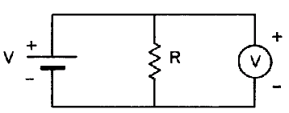

Using a multimeter (shown by the circle with a *V*) to measure the *voltage* across the resistor.

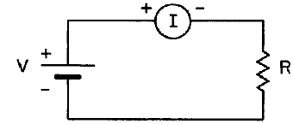

Using a multimeter (shown by the circle with an *I*) to measure the *current*, through the resistor.

1. Disconnect the circuit and then hook it up according to the *right* figure above. Measure the dc current. Note that you are measuring the current *through* the resistor, so the meter must be connected in series with the resistor.
2. Calculate the resistance value from the measurements above using Ohm’s Law.
3. Disconnect your circuit and reconfigure it with two batteries *in series* to obtain approximately 3 Volts (you connected two batteries in series in Experiment EO2) and repeat the voltage and current measurements. Calculate the resistance.
4. Repeat the above four steps for the 100 and 1k resistors.

**Analysis Questions**

1. For each resistor in Part II, your calculated resistance values should have been approximately equal. Were they? Explain why a material that obeys Ohm’s Law should have the same resistance for varying values of voltage and current.
2. A practical note is that commercially available resistors have a maximum power rating. You must be careful to ensure that the resistors you use for a project are sufficient for the power dissipated by your circuit. If you exceed the power rating of a resistor, you will permanently damage the resistor. The resistor may show visible darkening, it may melt, or even catch on fire. The resistors used in this experiment are rated for a maximum power of 0.25 W. Calculate the power dissipated by all three resistors in Part II, for both the one and two battery configurations. (You will have 6 different power values). Did you exceed the power rating of the resistor in any of these cases?
3. Now let’s say you also had a 10  resistor, and you had nominal voltages of 1.5 V for the one battery configuration and 3.0 V for the two battery configuration. Would you have exceeded the power rating of this resistor for either configuration?