**Experiment EO3: Capacitors**

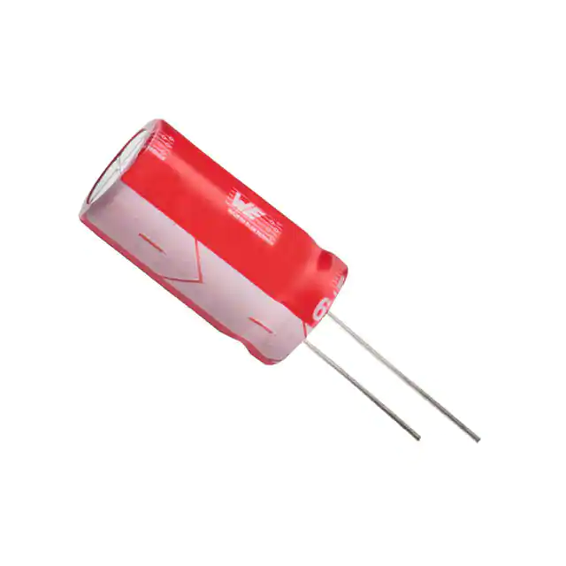

**Objectives**

* Learn about parallel-plate capacitors.
* Learn about multiple capacitors connected in parallel and in series.

**Introductory Material**

Capacitance is a constant of proportionality. It relates the potential difference *V* between two conductors to their charge *Q*. The charge *Q* is equal and opposite on the two conductors. The relationship can be written:



The capacitance *C* of any two conductors depends on their size, shape, and separation. The SI unit of capacitance is the Farad (F). One F is actually quite large. The capacitances you will be measuring today are in the nF-F range.

One of the simplest configurations is a pair of flat conducting plates, which is called a “parallel-plate capacitor.” Theoretically, the capacitance of a very large () parallel-plate capacitor is



where the subscript “*P*” denotes “parallel plate.” Here, *A* is the area of one of the plates, *d* is the distance between them, and 0 is a constant called the “permittivity of free space,” which has a value of 8.8542  10-12 F/m, in SI units.

We will now discuss how the capacitance of the parallel plates depends on the medium inserted between the plates. When there is a dielectric instead of a vacuum between the two capacitor plates, the capacitance *CPd* is given by:



where ** is the (dimensionless) dielectric constant of the material between the electrodes. Here is a table for some materials:

|  |  |
| --- | --- |
| Material | Dielectric Constant ** |
| Vacuum | 1 |
| Air | 1.00054 |
| Paper | 3.5 |
| Teflon | 2.1 |
| Water | 80 |

As you can see, although we have been neglecting the dielectric constant of air, the error we make in doing so is quite small.

symbol used for a capacitor in circuit diagrams

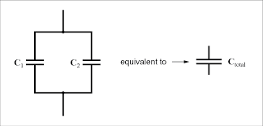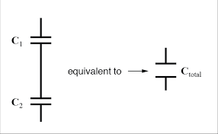

Schematic for two capacitors connected in parallel.

Schematic for two capacitors connected in series.

We will now discuss how capacitors are connected in circuits. In a circuit diagram, a capacitor is represented by two parallel lines, see the top figure above. Capacitors can be connected in parallel (above, left) or in series (above, right). When capacitors (or any circuit element for that matter) are connected in *parallel*, there are junctions, meaning that the wires split in different directions. When they are in *series*, there are no junctions. A circuit with all elements connected in series is one big loop. Nothing splits off in multiple directions.

The total capacitance *Ctot* of a set of capacitors in *parallel* is given by:



The total capacitance *Ctot* of a set of capacitors in *series* is given by:



**Experimental Procedure**

**Safety Concern:** While the capacitances of most capacitors you are dealing with here are small, some capacitors used in car stereo systems can reach a 1 F capacitance. Take care when working around capacitors – a charged capacitor can give you quite a shock.

Part I: Parallel Plate Capacitor

Watch the video found here (you only *need* to watch from about 1:40-3:20, but the whole video is good): <https://www.youtube.com/watch?v=3kfLDH1UbNo>

You will answer questions regarding the change in plate separation in the Analysis Questions.

A little later in the video he inserts a glass plate into the capacitor. Record the capacitance he measures with the glass plate in the capacitor. He then removes the glass plate. Record the capacitance he measures with the glass plate removed. Calculate the dielectric constant ** of the glass plate using Equation 3.3.

Part II: Capacitors in Parallel and in Series

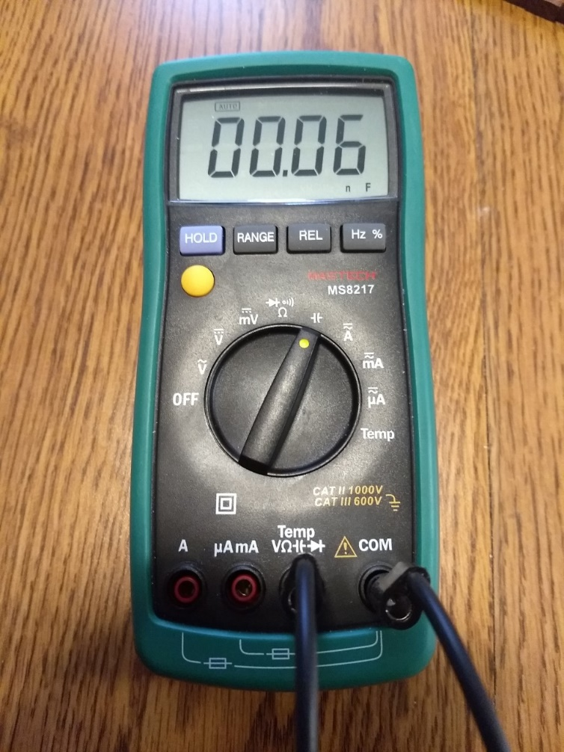You will now make measurements using a type of capacitor commonly used in electronic circuits. They are cylindrically shaped and look like the picture on the cover page. The settings used on the multimeter for these measurements are shown in the picture to the right. Note the setting on the dial and that the two rightmost ports are used.

You should first measure and record on your worksheet the capacitance of each of your 4 capacitors. This will serve two purposes:

* It will confirm that you are measuring the capacitance correctly.
* It will verify that the capacitance is (approximately) the value that appears on the side of each capacitor.

If you have the alligator clips attached to the banana plug leads from the multimeter, simply clip one lead to each side of the capacitor and use the meter as shown to the right to record the capacitance of each individual capacitor.

**Note:** These capacitors are *polarized*, which means there is a difference between the positive and negative sides. The positive side has a longer wire. If you were using them in an actual circuit, you would have to pay close attention to this polarity. For the purposes of this lab, however, the direction that the capacitors are connected does not appear to affect the capacitance values.

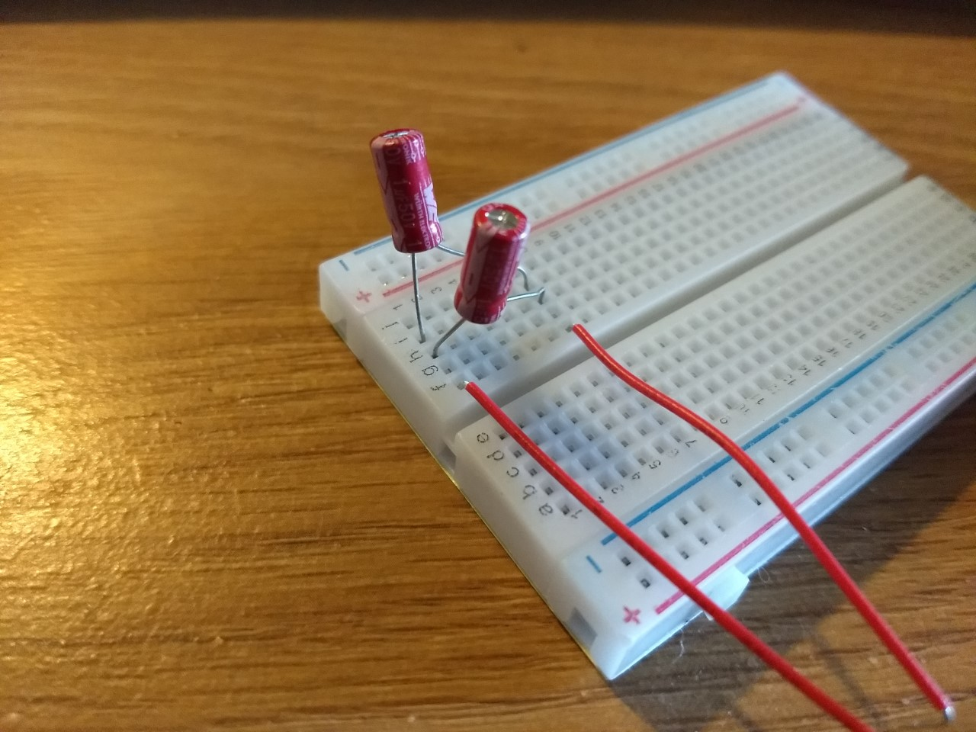

*Capacitors in Parallel*

To connect multiple capacitors together in various combinations, we will use the breadboard. Connect the two 1 F capacitors in parallel as shown above. Make sure that you understand why the picture on the left and the schematic on the right are equivalent (You may need to look back at the breadboard pattern you investigated in Experiment EO1). The next time you are asked to connect capacitors in parallel, you will only be given the circuit diagram. Measure the total capacitance *Ctot* of these two capacitors connected in parallel and record on your worksheet.

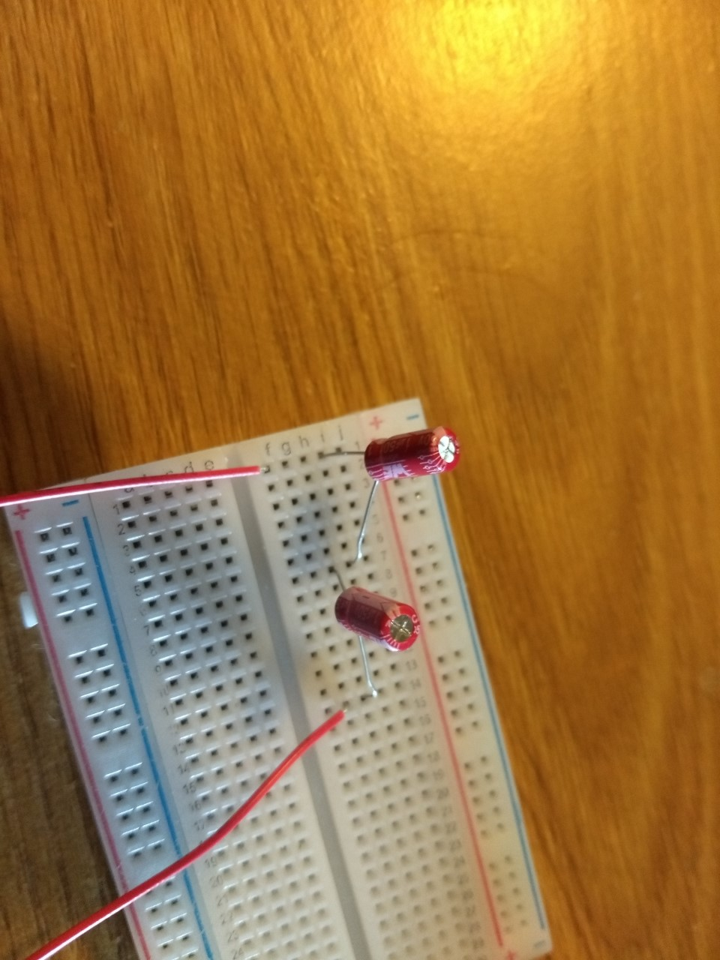



*Capacitors in Series*

Connect the two 1 F capacitors in series as shown above. Make sure that you understand why the picture on the left and the schematic on the right are equivalent (You may need to look back at the breadboard pattern you investigated in Experiment EO1). The next time you are asked to connect capacitors in series, you will only be given the circuit diagram. Measure the total capacitance *Ctot* of these two capacitors connected in series and record on your worksheet.

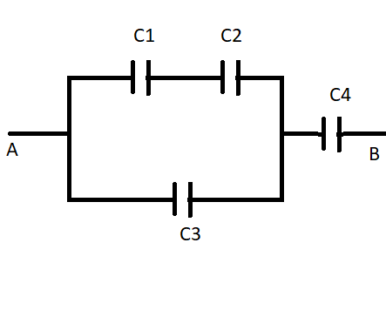*Capacitors in Parallel and Series Combinations*

Using the breadboard, connect the four capacitors as shown in the schematic above. Use these capacitance values: C1=10 F, C2=1 F, C3=10 F, and C4=1 F. Measure the total effective capacitance *Ctot* of the entire combination and record on your worksheet. Take a picture of your assembled capacitor combination and paste it into your worksheet.

**Analysis Questions**

1. In the video you watched, what happened to the capacitance when the plate separation *decreased*? Explain why this should be the case, and make sure to cite the relevant equation from the Introductory Material.
2. For the two capacitors connected in parallel, calculate the *expected* value of *Ctot*, using the measured capacitances from Table 2 on your worksheet. Compare to your *measured* value of *Ctot* (Table 3) using a percent error: .
3. For the two capacitors connected in series, calculate the *expected* value of *Ctot*, using the measured capacitances from Table 2 on your worksheet. Compare to your *measured* value of *Ctot* (Table 4) using a percent error.
4. For the combination of four capacitors in the last part of the experiment, calculate the *expected* value of *Ctot*, using the measured capacitances from Table 2 on your worksheet. For this calculation you cannot simply use just Equation 3.4 or Equation 3.5 all in one shot. You will need to break it into pieces. Compare to your *measured* value of *Ctot* (Table 4) using a percent error.

**Hint:** Can you find the equivalent capacitance of the C1 and C2 combination of capacitors? Then what could you do to reduce the situation further?