Experiment EO2: Equipotentials and Field Lines
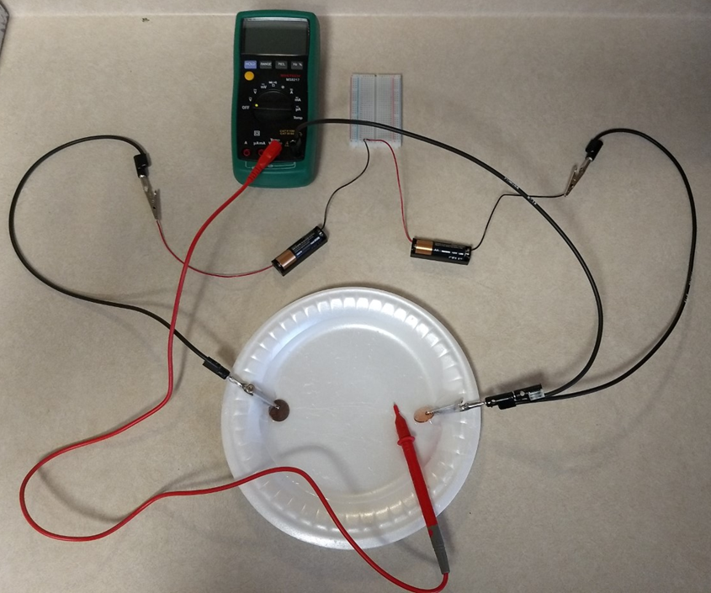
Objectives
- Learn about the relation of equipotential contours and electric fields.
- Map equipotential contours around two pennies used as electrodes.
- Determine the electric fields around the electrodes.

Introductory Material
The electric field E at a point in space is defined as the force F exerted on a small electric charge q (located at that point), divided by q:
Note that E and F are both vector quantities.

As you may recall from mechanics, the work W done in moving an object a distance Δx is simply:

The potential difference ΔV between two points is defined as the work done in moving a test charge q from one point to the other (over a distance of Δx), divided by q:
If we solve Eq. 2.1 for the magnitude of the force F and substitute it into Eq. 2.3, we can then solve for the magnitude of the electric field, E:
Note that the electric field E can be expressed in V/m (as can be seen from Eq. 2.4), or in N/C (as can be seen from Eq. 2.1).

We will map the equipotential contours around two pennies used as electrodes. These electrodes are conductors, and recall that the surface of a conductor itself is an equipotential. We will then calculate the strength of the field at various points. We can compare the relative values of the fields at various points with the values predicted by the theory for static charges.

Note: Electric field lines point away from positive charges and towards negative charges.

How the experiment works
- In this experiment, you will measure the potential not in free space, but in a shallow amount of saltwater on a Styrofoam plate.
- The saltwater is not a good conductor, but current can flow through it well enough that you can measure potentials.
- We can locate points on the plate that have a specified potential V. Lines connecting these points are equipotential contours.
- The electric field must be at right angles to these lines, for if it were not, the component of force along a line would lead to work being done to move a charge along the line, contrary to the initial assumption.
- If we locate a series of equipotential contours, we can then draw in the electric field lines by keeping the equipotentials and field lines at right angles everywhere they cross.
- E is given, in magnitude, by Eq. (2.4) where Δx is the shortest path between two equipotential contours with a potential drop ΔV between them.

Example: Parallel Plates
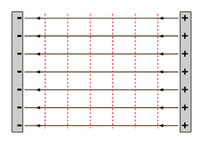

In the experimental portion of this lab you will determine the equipotential contours and electric field lines for two pennies used as electrodes, which approximate two point charges. Here we look at an example of what the equipotentials and field lines look like for a different electrode configuration – parallel plates. See the picture above. The left plate is negatively charged, and the right plate is positively charged. The magnitude of the charge on both plates are equal. Here the equipotential lines (vertical dotted lines) are simply straight lines, equally spaced between the plates. As the electric field lines must be perpendicular to the equipotentials, they must be straight, horizontal lines. As the electric field lines point away from positive charges and towards negative charges, the electric field points towards the left, as indicated by the arrows in the figure.

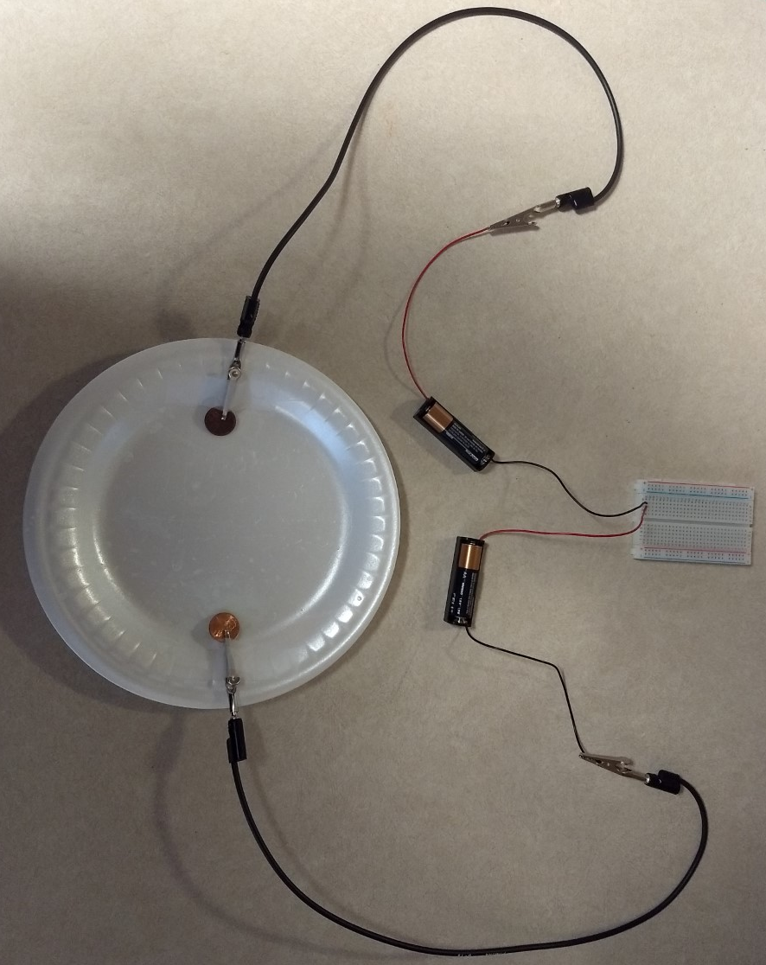
Experimental Procedure
Part I: Setup

Begin by assembling the equipment as shown in the picture above. In this step you are using the batteries to provide a potential between the two pennies. Using alligator clips and the banana plug leads connect the pennies to the batteries as shown. Use the breadboard to connect the batteries in series (both batteries should be connected to the same conductive strip of the breadboard). Use scotch tape to securely fasten the penny electrodes to the Styrofoam plate (While Styrofoam is ideal, any disposable plate where you can scratch the bottom with the multimeter probe will do). Add a teaspoon or so (exact amount is not important) of salt to a cup of water and stir. If you don’t have any salt, tap water may be conductive enough on its own, especially if you have hard water. Pour water on the plate so that the pennies are at least halfway submerged. Once you have added the saltwater you should disconnect one of the wires from the breadboard to save battery life. Remember to reconnect it before making your measurements in Part II!
If everything is connected properly, one penny is positively charged and the other is negatively charged (Do you know which one is which?). There is a potential which varies as you move across the plate, and there is an electric field whose value and direction will vary as you move around the plate.
The next step is to connect the multimeter and probe that will allow you to find your equipotential curves. Add in the multimeter and probe as shown in the picture below. You will connect the multimeter probe to the multimeter port for making voltage measurements. Connect one end of a banana plug lead to the COM port on the multimeter, and stack the other end of the lead onto the banana plug lead connected to the penny on the right. If everything is connected properly, you will now be able to use the multimeter to measure the potential between the penny on the right and the location of the multimeter probe.
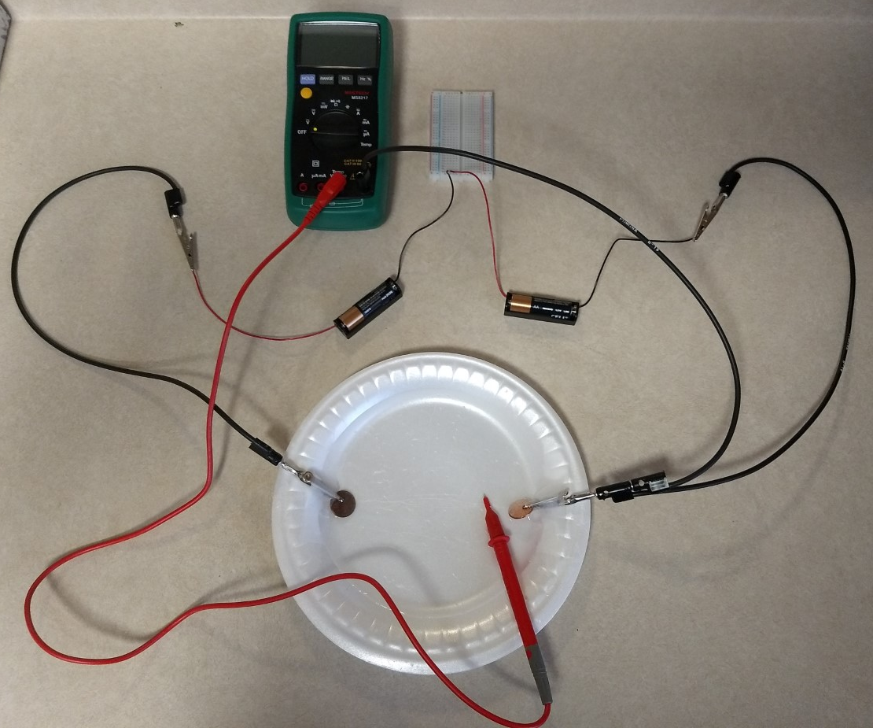

Part II: Mapping the Equipotentials and Field Lines
If you disconnected one of the battery holder wires from the breadboard earlier to save battery life, reconnect it now. Turn on the multimeter and set the dial to the DC voltage setting. Put the sharp metal tip of the multimeter in the saltwater. As you move it around, you should notice the voltage reading on the multimeter changing. If you have connected everything as shown in the picture above, you should see the voltage increase as you move the probe from right to left.
You are now ready to find 7 equipotential contours. An equipotential contour is a line where all points on that line have the same voltage. To find the first equipotential contour:
- Place the probe in the water approximately midway between the two pennies. Press the sharp tip of the probe into the plate so that leaves a mark. Make sure not to push so hard that it makes a leak in the plate! Record the voltage on your worksheet.
- Move the probe about 1 cm in a direction that keeps the voltage reading the same (to within about 0.01 V). Mark the plate with the probe again.
- Continue moving the probe and marking the plate at points with the same voltage until you have created a line across the whole plate.
Using the procedure above, mark three more equipotential contours to the left of your central contour, and three more to the right of your central contour for a total of 7 contours. Make sure to make your left-most and right-most contours very close to the pennies. You should notice that as you approach the pennies your contours become increasingly curved.
Once you have marked points with the probe for all 7 equipotential contours, disconnect the batteries and remove the pennies/clips/leads from the plate. Pour off the water and dry the plate. Now use a marker or pen to draw the contours “connect the dots” style. Label each contour with its voltage.
Examine the equipotential pattern that you have drawn. Draw in the electric field lines remembering that they:
- exit the positive electrode at a right angle to its surface
- are everywhere at right angles to the equipotential contours
- end on the negative electrode, at a right angle to its surface.
Put arrows on your field lines to indicate direction.
Calculate the electric field strength at one point on the parallel plate plot as follows:
- Mark on your plot a point a centimeter or two from the center. It’s best to choose a point that is about halfway between two contours.
- Identify the two nearest contours that straddle your point.
- Draw the shortest possible straight line that passes through your point, starting on one of the contours and ending on the other.
- Use a ruler to measure the spacing Δx between the contours at the two points.
- Calculate E, using Eq. (2.4).

Analysis Questions
- Consider the equipotential contours near conductor surfaces. Why are they parallel to the surface?

- Is it possible for two different electric field lines to cross? Explain. (Hint: Remember, field lines have a direction.)

- Using Equation 2.4, explain why the field is stronger when the equipotential contours are closer together, and weaker when the contours are farther apart.

- Sketch the equipotential contours you would expect for the “point and plane” configuration of electrodes shown below. Show at least 7 contours. Then draw in the electric field lines, including the direction. Show at least 7 field lines.

If you have access to a printer: Print off the electrode configuration, draw in the equipotential contours and field lines by hand, take a picture of your drawing, and paste it into your worksheet.

If you do not have access to a printer: Draw the electrode configuration shown below on a piece of paper, draw in the equipotential contours and field lines by hand, take a picture of your drawing, and paste it into your worksheet.

Hints:
- You may find it helpful to look at the parallel plate example from the Introductory Material and your experimental results for the pennies.
- You could also try figuring it out experimentally by replacing one of the pennies with a long straight electrode (maybe a straightened out paperclip?), and repeating the experimental portion of the lab.

-

