Experiment EO1: Multimeters and Breadboards
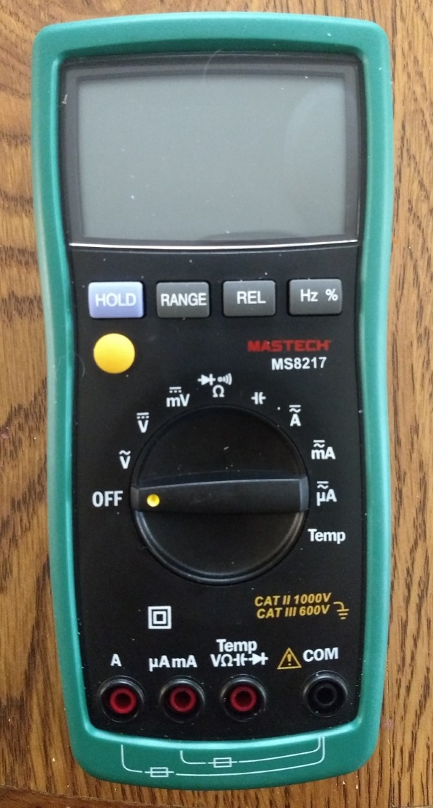
Objectives
- Become familiar with multimeters.
- Become familiar with breadboards and jumper wires.

Introductory Material
This first laboratory experiment in not properly an experiment at all. It is an introduction to using the most common equipment that you will be using throughout this lab course. This equipment is shown and labeled in the pictures below.
Multimeter: A multimeter is an instrument used to measure various electrical properties. For this course you will need a multimeter that measures current, voltage, resistance, and capacitance. The pictures and instructions throughout this course will be for the Mastech MS8217 multimeter. Another brand/model of multimeter that measures these same quantities will work for this course, but you may need to consult the owner’s manual if it differs significantly from the model shown. Examine your meter carefully. Notice that there are multiple dial settings. Also notice the connection ports at the bottom. While you will always use the “COM” port, the other port used depends on the quantity you want to measure!
Banana Plug Leads: Banana plug leads plug into the ports at the bottom of the multimeter. They can also be used to connect various electrical components assuming that the proper ports are available.
Alligator Clips: Alligator clips are used to connect the banana plug leads to bare wires. Simply slide the cylindrical end of the clip over the banana plug and attach the clip end to the wire.
Breadboard: The breadboard is a convenient tool for creating temporary circuits. Wires and various components (such as resistors and capacitors that you will study later in this course) can be inserted into the board to create the desired circuit, and then easily removed.
Jumper Wire Kit: You can use the jumper wires to connect to the breadboard, as well as to connect various components on the breadboard to each other.
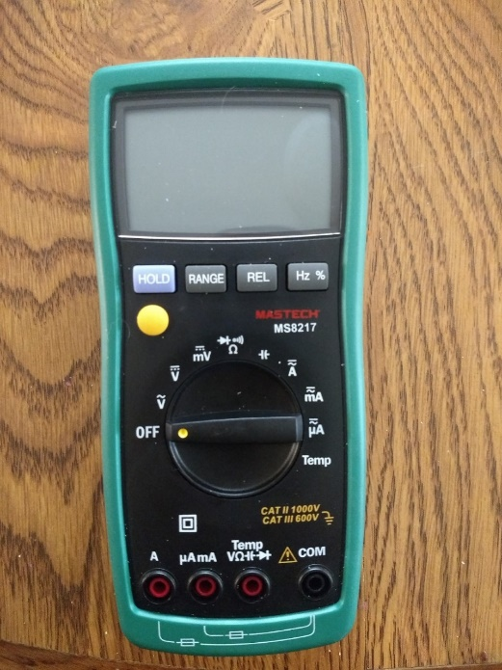
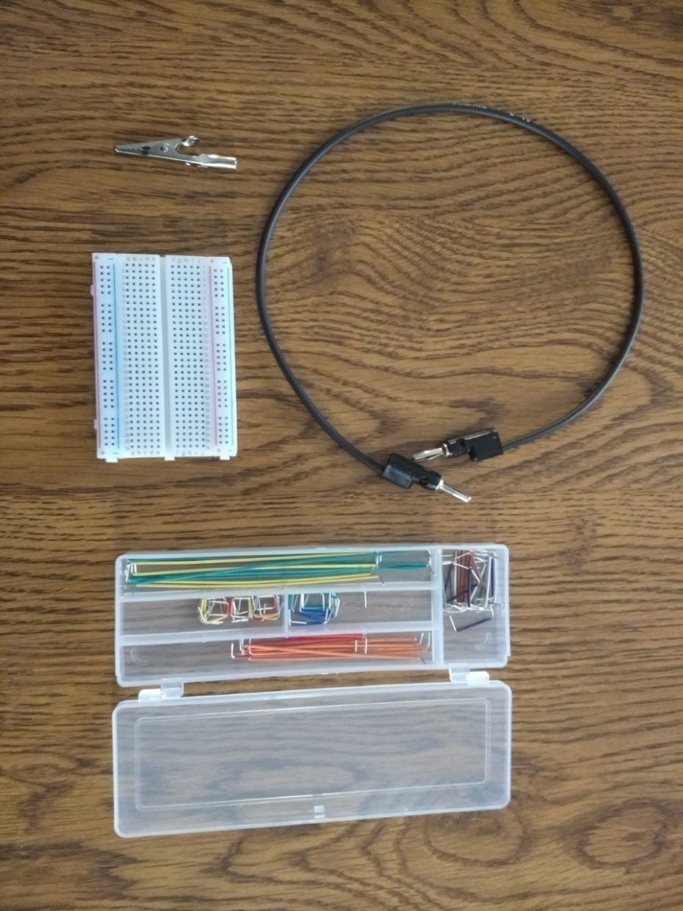
Multimeter
Banana Plug Lead
Breadboard
Jumper Wire Kit
Alligator Clip
Experimental Procedure
You will be measuring several electrical quantities today in the process of learning how to use the equipment. The concepts behind these quantities will be developed much more thoroughly in the lecture component of the course as the term goes on. So if you feel like you don’t really understand the concepts of resistance, voltage, and current, that’s not only OK, but expected. We have to measure SOMETHING to learn how the equipment works!
Part I: Measuring Resistance to Determine Electrical Continuity
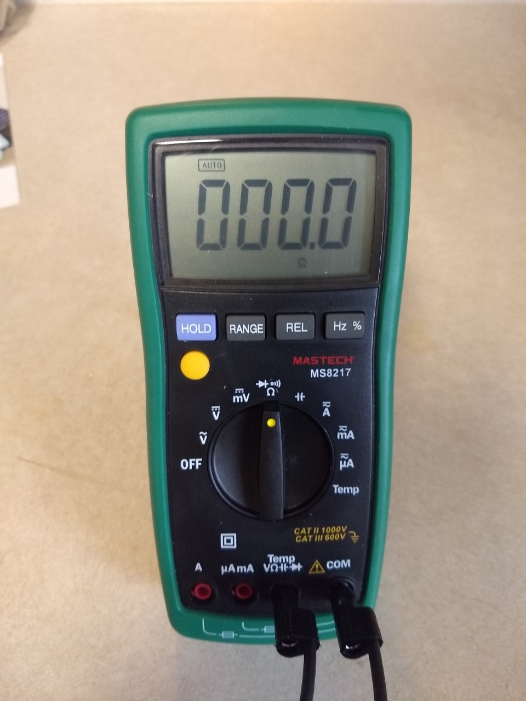
You will discuss the concept of resistance more thoroughly later in the course. For now, it is enough to know that the resistance of a material is a measure of how much that material impedes the flow of electrical current. Resistance is measured in Ohms (Ω). A resistance of 0 Ω means that there is nothing to impede the flow of current. A higher resistance means that it is more difficult to make the current flow.
Multimeter configuration for measuring resistance.
To measure resistance, connect two banana plug leads to the multimeter using the ports shown in the figure to the right. No matter what quantity you are measuring, one lead is always connected to the “COM” port. In this case, you are measuring resistance, and note the “Ω” symbol on the other port used. Turn the meter’s dial to the resistance setting. Once again, this meter uses the “Ω” symbol to indicate resistance. Use this exact multimeter configuration any time you are required to measure resistance later in this course.
To visualize how a resistance measurement can indicate electrical continuity, hold the leads up in the air so they are not touching each other or any surface. Make sure you are holding the leads by the plastic insulation and not touching the metal ends. The multimeter should read 0.L (overload), indicating that the resistance is too large to make a reading. Indicate the meter reading on your worksheet. In this case you can see that there is no electrical continuity because the leads are not touching each other. A resistance so large the meter cannot read it means that it is so difficult for current to flow that you do not have electrical continuity, just what you’d expect for wires that aren’t touching.
Now stack the ends of the leads not connected to the multimeter as shown below. The multimeter should now read 0 or very close to it. Record this reading on your worksheet. No or very little resistance means that current would flow easily between the leads, which is exactly what you expect if two wires touch each other.
We just looked at the two extreme cases:
- one where the wires were not touching at all and the resistance was so high that it could not be measured. There was no electrical continuity in this case.
- another where the wires were directly connected and there was practically zero resistance, indicating electrical continuity.

Now let’s look at something in-between. Unstack the plugs and hold one end tightly in each hand. While the multimeter display will likely be unsteady, take careful note of the scale: You will likely see a reading in kΩ or MΩ.. Record this on your worksheet. So, what does this mean? This indicates that if you have a high enough voltage that your body WILL conduct electricity. You’ve likely touched both ends of a AA battery without even thinking about it, and you felt nothing. That’s because your body resists the flow of electricity too strongly for a small battery to create an electrical current. But a higher voltage, such as that supplied by touching bare wires in home electrical wiring, will allow current to flow, and can cause a painful and possibly very harmful electrical shock.

So what resistance constitutes electrical continuity? Well unfortunately the answer isn’t so simple. It depends on the circumstance. If you are simply checking two ends of an insulated wire, a resistance of more than a couple of ohms probably means the metal wire inside is broken and you do not have electrical continuity. If you are checking an entire circuit or device, several hundred or even several thousand ohms may indicate electrical continuity.
Part II: Examine the Breadboard
The breadboard has holes that allow you to connect jumper wires and other components. Inside the board are conducting metallic strips. If you select two holes at random, you may select two holes on the same strip, or two holes on a different strip. You need to know the pattern in order to effectively use the breadboard. While we could just inform you of this pattern outright, it will be instructive for you to use the resistance setting on the multimeter to determine it for yourself.
You can connect the holes of the breadboard to the multimeter as shown in the picture below. Attach the alligator clip to the banana plug lead. One end of the jumper wire is pushed into a hole on the end of the breadboard, and the alligator clip is clipped to the other end.

Use the resistance setting on the multimeter to determine the pattern of the conducting metallic strips on the breadboard. Any two holes on the same strip will have a resistance very close to 0 Ω. Any two holes not on the same strip will have such a high resistance between them as to give a resistance reading of 0.L (overload). Check the resistance between enough sets of holes on the breadboard to determine a pattern. Note that you will not have to check that many sets to determine the pattern if you choose your test cases carefully. When choosing your test cases, make sure that you:
- test in both the horizontal and vertical direction
- check to see the effect of crossing the central “trough”
- carefully test how the red (+) and blue (-) lines work.
Once you have determined the pattern, indicate this pattern on the breadboard picture included on your worksheet. An INCORRECT example is shown in the picture below. If you’re doing this in Word, the easiest way to draw the lines is to go to the “Insert” menu, choose “Shapes” and then “Line”. Alternatively, if you have access to a printer, you could print off the worksheet, draw your lines in by hand, take a picture, and paste it into your worksheet.
Note that you do not need to draw lines across the entire picture of the breadboard. Draw enough lines to thoroughly convince your TA that you understand the pattern. If you choose your lines carefully, this can probably be done in as few as 8 lines.

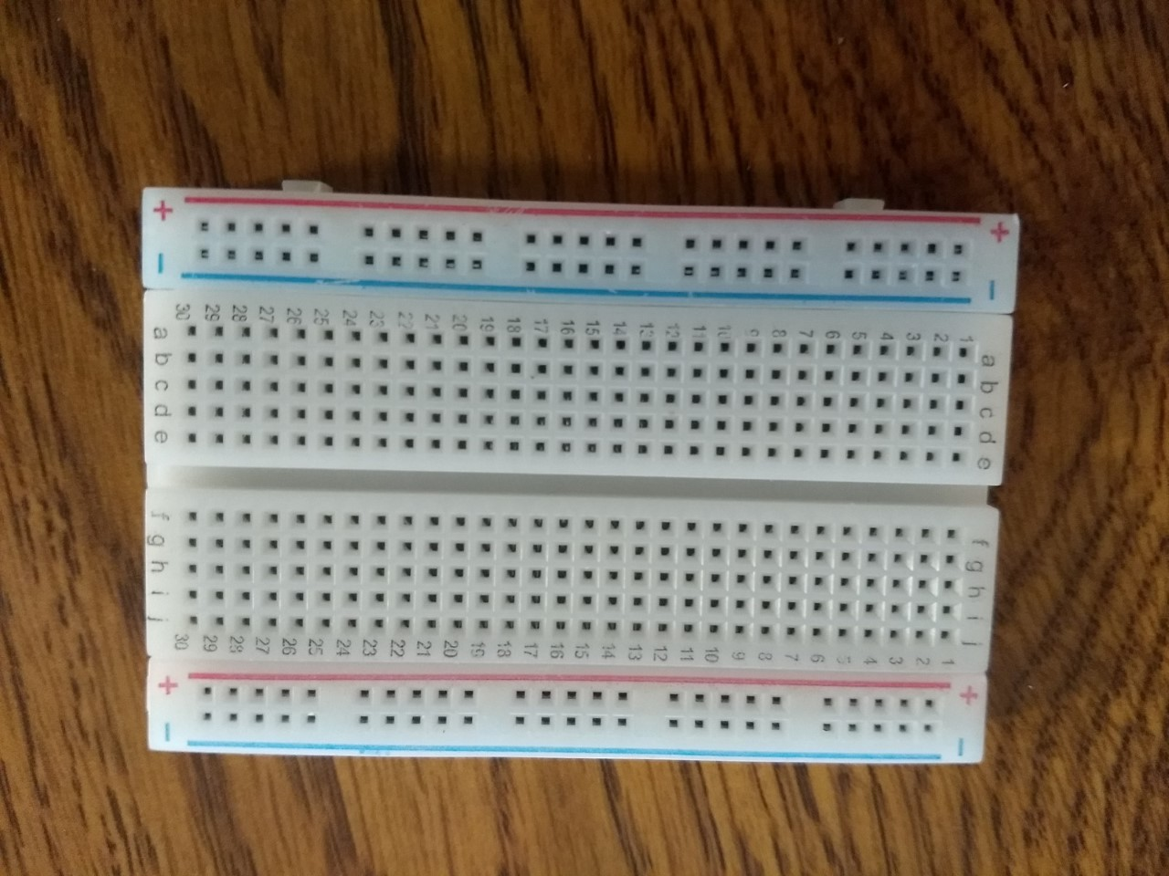
INCORRECT example of lines drawn on the breadboard to indicate location of conducting metallic strips.

Part III: Measure the Voltage Across a Circuit Element and the Current Through It
In this part of the lab you will learn how to make voltage and current measurements using a multimeter. Note that you will learn more about the concepts of voltage and current later in this course, as well as why you will make these measurements in the way described. For now, just note that these are the proper procedures for making such measurements, and it is the way you will be expected to do so throughout this lab course.
Important note: In some cases a failure to use the correct ports, settings, and wiring can cause you to blow a fuse on the multimeter! If you blow a fuse on your multimeter, you will have to buy a new fuse and replace it yourself!
Current
If you have not already done so, insert a AA battery into one of your battery holders. Create a circuit using the battery, the multimeter, and a 100 Ω resistor as shown in the picture. See the pictures on the next page for a close-up on which ports to use on the meter (“COM” and “μAmA”) and for the jumper wire and resistor connections on the breadboard.
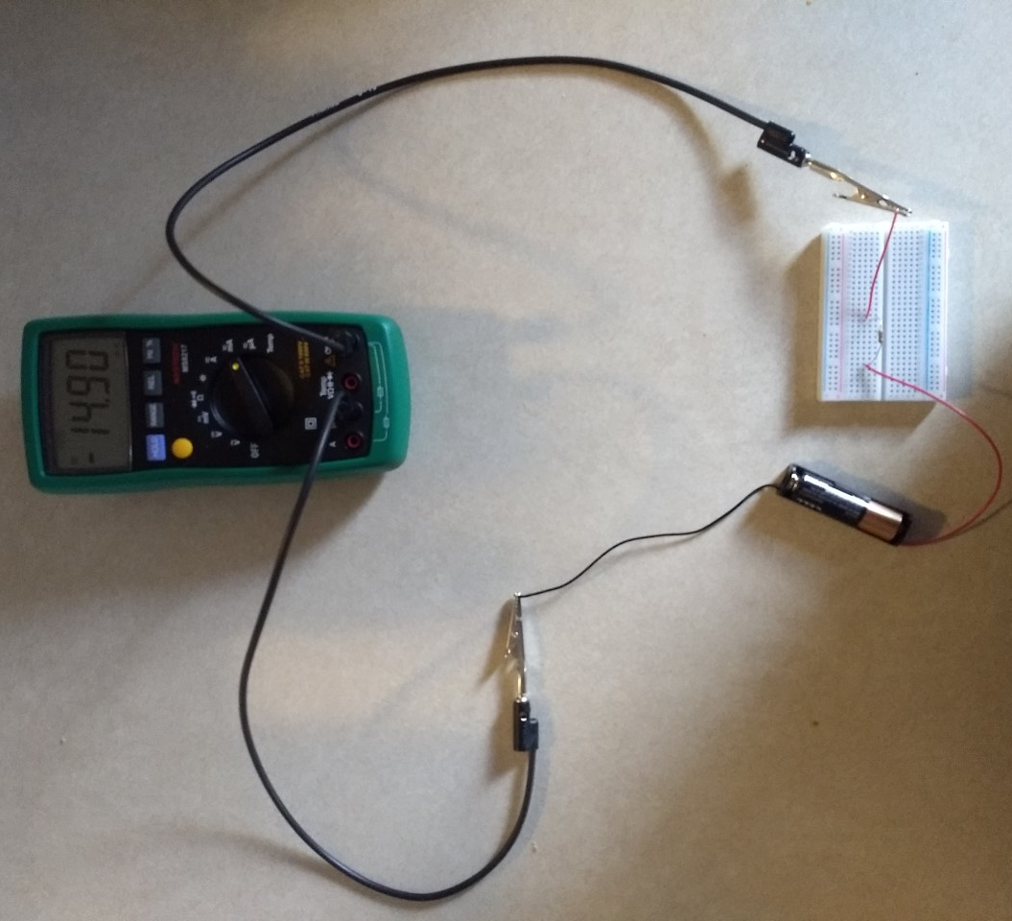

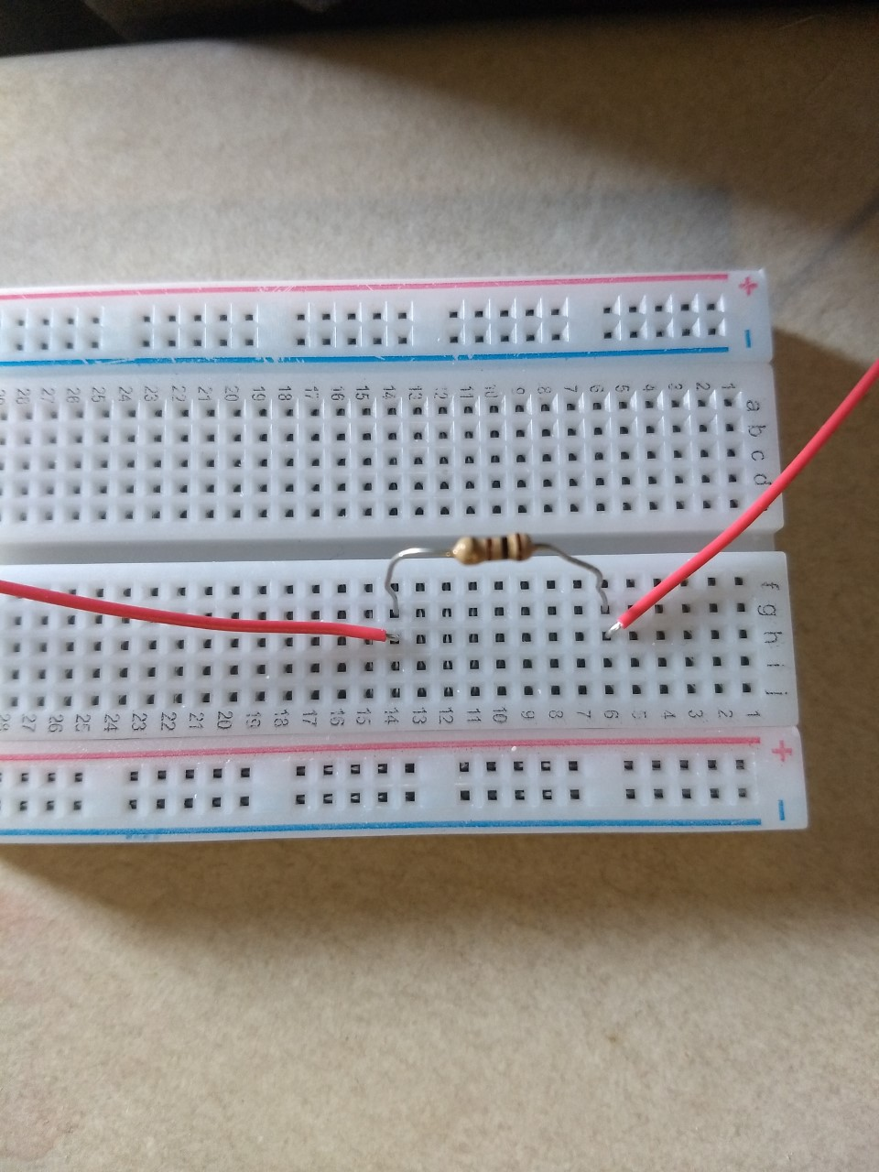
Correct multimeter ports for small current measurements and closeup on breadboard for wire connections to measure current through the resistor.

Note that your circuit is essentially one giant loop, with your multimeter in line with the resistor and other connecting wires/leads. This is referred to as being “in series” with the resistor. When you want to measure the current THROUGH a circuit element your meter must be in series with that element. You will learn more about why this is the case later in the course.
Now turn the dial on the multimeter to the mA setting. In addition to the current reading, your meter display should also indicate “DC” for a direct current reading. If it reads “AC” push the yellow button near the top left to change the mode of measurement. Record the current on the worksheet. Disconnect a wire as soon as you are done with this measurement to stop the drain on the battery.
Voltage
Now you will measure a voltage. Note that you will not simply turn the dial to the Voltage setting. You need to use a different port on the multimeter, AND you need to change how the multimeter is connected to the board.
Redo your circuit as shown in the figure on the next page. See the pictures on page 9 for closeups on which ports to use (“COM” and the one that includes “V”) and for the jumper wire and resistor connections on the breadboard. When connected this way, the multimeter is said to be “in parallel” with the resistor. When you want to measure the voltage ACROSS a circuit element, you meter must be in parallel with that element. You will learn more about why this is the case later in the course.
Now turn the dial on the multimeter to the DC voltage setting (the V with a straight line across the top – the V with the curvy line is for AC voltage, which you are not dealing with here). Record the voltage on your worksheet and disconnect the circuit.

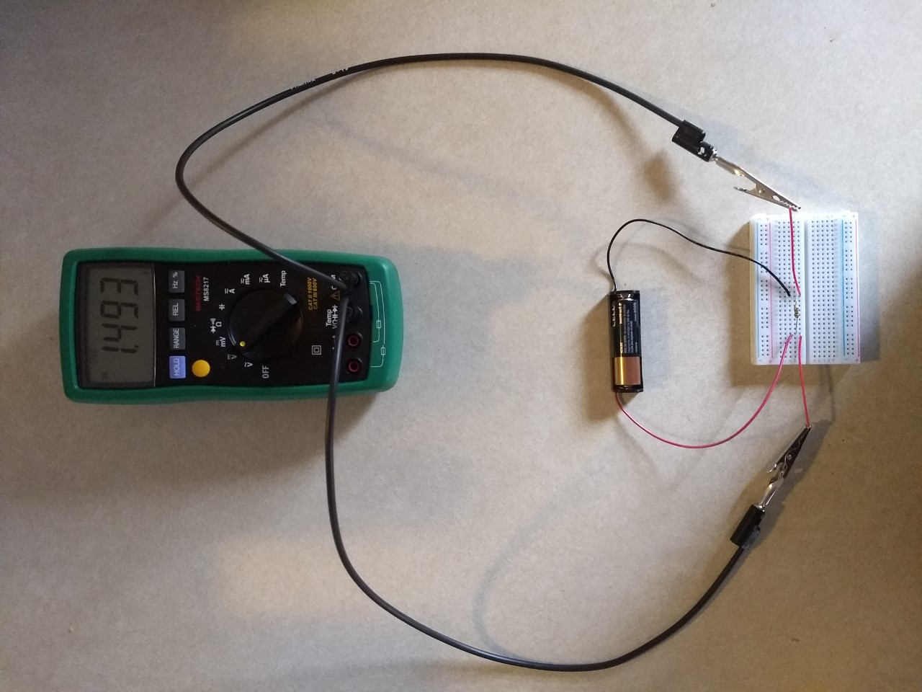

Correct multimeter settings for voltage measurements and closeup on breadboard for wire connections to measure the voltage across the resistor. In case it is not clear from the picture, a wire from the battery, one end of the resistor, and a wire from the multimeter are connected in that order, top to bottom, in the same column of holes. The same is true for the right side.

Analysis Questions
- Explain how the breadboard connections used for both measurement in Part III are consistent with the breadboard pattern you determined in Part II.

- If you have just correctly made a current measurement through a circuit element, can you simply turn the multimeter dial to the voltage setting to measure the voltage across the same element? If not, what must you do differently?

